ASSIGNMENT REPORT-4

Submitted by:
LAKSHMI MAYURI KAVYA N [26120161] AKASHKUMAR A H [26120105]

Under the guidance of:
HEMA ARUNACHALAM MURTHY

For The Subject

Pattern Recognition and Machine Learning
(26AI5707)



DEPARTMENT OF ARTIFICIAL INTELLIGENCE AND DATA SCIENCE
SHIV NADAR UNIVERSITY
KALAVAKAM

SEPTEMBER 2026

INTRODUCTION:
In this assignment we studied the geometric properties of 2-dimensional multivariate Gaussian distributions under three different forms of the covariance matrix:
- Isotropic covariance – C = σ²I (circular contours)
- Diagonal covariance – axis-aligned elliptical contours
- Full covariance – rotated elliptical contours
For each case we generated synthetic data (N = 1000), estimated the sample mean and covariance, computed eigenvalues and eigenvectors, and plotted the constant-density curves together with the principal axes. Finally we generated data from two different Gaussian classes and examined the resulting Bayes decision boundary.

OBJECTIVE:
Our Objective is to:
- Generate 2-D data from Gaussian distributions with different covariance structures.
- Estimate mean vectors and covariance matrices from the generated samples.
- Compute and visualise eigenvalues and eigenvectors of the covariance matrices.
- Plot constant-density curves defined by (x − μ)ᵀ Σ⁻¹ (x − μ) = c and
- Study the nature of the decision boundary between two Gaussian classes.

METHODOLOGY
1.Data Generation
We generated the data ourselves instead of using any ready-made dataset. For the normal cases we used the formula:
Y = μ + Σ½ X,
where X is drawn from a standard normal distribution (mean 0 and variance 1).
For the isotropic case (Part 1), we generated two independent 1-D Gaussian samples with variance σ² = 1 and combined them to form 2-D points. In every experiment we used 1000 samples.

2.Parameter Estimation
After generating the data, we have to calculate the sample mean and the sample covariance matrix. Then we found the eigenvalues and eigenvectors of the estimated covariance matrix. The square root of the eigenvalues tells us the length of the major and minor axes of the ellipse, and the eigenvectors tell us the direction of those axes.

3.Constant Density Curves
The constant density curves of a 2-D Gaussian are ellipses given by the equation
(x − μ)ᵀ Σ⁻¹ (x − μ) = c.
To plot them we evaluated the Gaussian density on a grid and drew contour lines. We also drew the eigenvectors (scaled by √λ) on the same plot so that the major and minor axes are clearly visible.

RESULTS AND OUTPUT:
Part 1 – Isotropic Covariance (C = σ²I)
True parameters: μ = [0, 0]ᵀ , Σ = I

Console Output:
True mean : [0. 0.]
Estimated mean: [0.01933206 0.07083624]

True covariance:
[[1. 0.]
[0. 1.]]

Estimated covariance:
[[ 0.95886385 -0.03945949]
[-0.03945949 0.99491523]]

Eigenvalues (sorted): [1.0202713 0.93350778]
Eigenvectors:
[[ 0.54059545 -0.84128269]
[-0.84128269 -0.54059545]]
sqrt(eigenvalues) = major/minor axis lengths (1σ): [1.0100848 0.96618207]
Estimated mean | [0.0193, 0.0708]
Estimated covariance | [[0.9589, −0.0395], [−0.0395, 0.9949]]
Eigenvalues | 1.0203 , 0.9335
Axis lengths (√λ) | 1.0101 , 0.9662

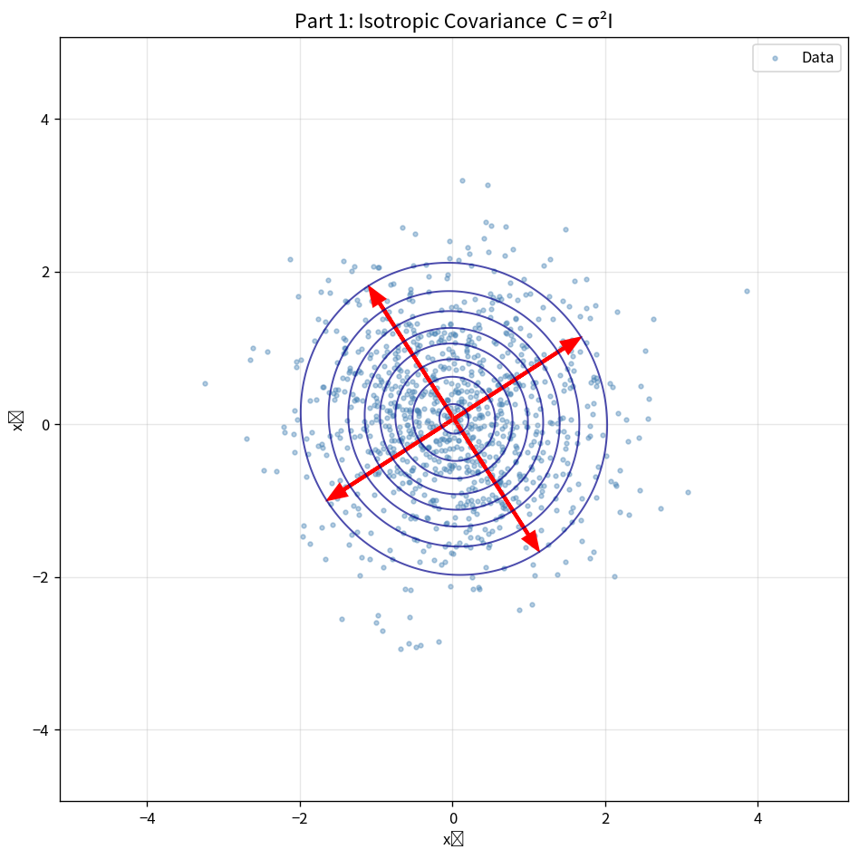
Observation - Isotropic Covariance:
The points formed almost a circle. Both axes were nearly equal in length, which is expected when the covariance is just σ²I. The small difference we see is only because of the limited number of samples.

Part 2 – Diagonal Covariance
True parameters: μ = [1, 2]ᵀ , Σ = diag(3, 1)
Console Output:
True mean : [1. 2.]
Estimated mean: [0.98126368 1.99793242]

True covariance:
[[3. 0.]
[0. 1.]]

Estimated covariance:
[[3.04930279 0.06617622]
[0.06617622 1.0060127 ]]

Eigenvalues (sorted): [3.0514438 1.00387169]
Eigenvectors:
[[ 0.99947705 -0.03233627]
[ 0.03233627 0.99947705]]
sqrt(eigenvalues) = major/minor axis lengths (1σ): [1.74683823 1.00193398]
Estimated mean | [0.9813, 1.9979]
Estimated covariance | [[3.0493, 0.0662], [0.0662, 1.0060]]
Eigenvalues | 3.0514 , 1.0039
Axis lengths (√λ) | 1.7468 , 1.0019

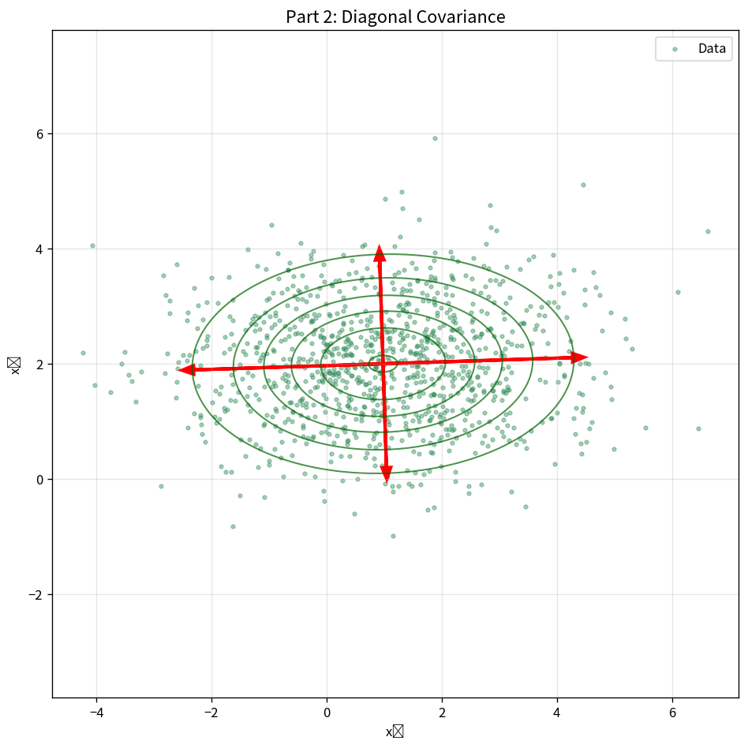
Observation- Diagonal Covariance:
The cloud of points became stretched along the x-axis because the variance in x₁ is larger (3) than in x₂ (1). The ellipses are not tilted — they stay aligned with the coordinate axes.
Part 3 – Full Covariance
True parameters: μ = [0, 0]ᵀ , Σ = [[2.0, 1.2], [1.2, 1.5]]
Console Output:
True mean : [0. 0.]
Estimated mean: [-0.08306473 -0.08053769]

True covariance:
[[2. 1.2]
[1.2 1.5]]

Estimated covariance:
[[1.91690706 1.14672737]
[1.14672737 1.49808501]]

Eigenvalues (sorted): [2.87318752 0.54180455]
Eigenvectors:
[[ 0.76799913 -0.64045089]
[ 0.64045089 0.76799913]]
sqrt(eigenvalues) = major/minor axis lengths (1σ): [1.69504794 0.73607374]
Estimated mean | [−0.0831, −0.0805]
Estimated covariance | [[1.9169, 1.1467], [1.1467, 1.4981]]
Eigenvalues | 2.8732 , 0.5418
Axis lengths (√λ) | 1.6950 , 0.7361

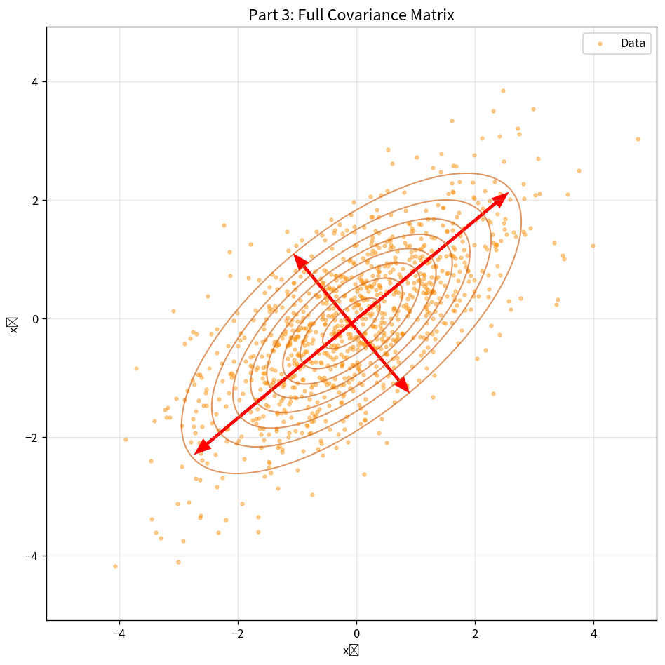
Observation-Full Covariance:
Now the ellipses are tilted. This happens because of the off-diagonal terms (correlation) in the covariance matrix. The red arrows (eigenvectors) show the new directions of the major and minor axes.

Part 4 – Two Classes and Decision Boundary
Experiment 1: Different Covariances
Class ω₁: μ₁ = [−2, −1]ᵀ , Σ₁ = [[1.5, 0.6], [0.6, 1.0]]
Class ω₂: μ₂ = [2.5, 1.5]ᵀ , Σ₂ = [[1.0, −0.4], [−0.4, 2.0]]

Console Output:
Class ω₁ estimated parameters:
μ̂₁ = [-1.98259354 -1.02342698]
Σ̂₁ =
[[1.62287986 0.5922114 ]
[0.5922114 1.01490609]]
Class ω₂ estimated parameters:
μ̂₂ = [2.47010085 1.54816514]
Σ̂₂ =
[[ 1.02310637 -0.40123907]
[-0.40123907 1.86985165]]

Parameter | Class ω₁ | Class ω₂
Mean | [−1.9826, −1.0234] | [2.4701, 1.5482]
Covariance | [[1.6229, 0.5922], [0.5922, 1.0149]] | [[1.0231, −0.4012], [−0.4012, 1.8699]]

Observation(Experiment1):
The two classes have different shapes and orientations. Because their covariance matrices are not the same, the decision boundary between them is curved (quadratic).
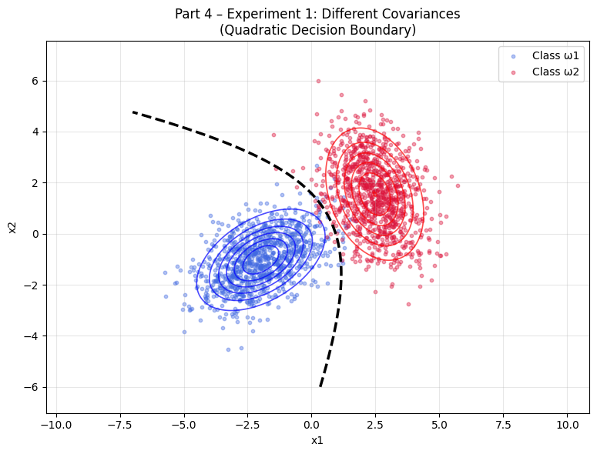

Experiment 2: Same Covariance
Both classes were given the same covariance matrix:
Σ = [[1.5, 0.4], [0.4, 1.2]] but different means.

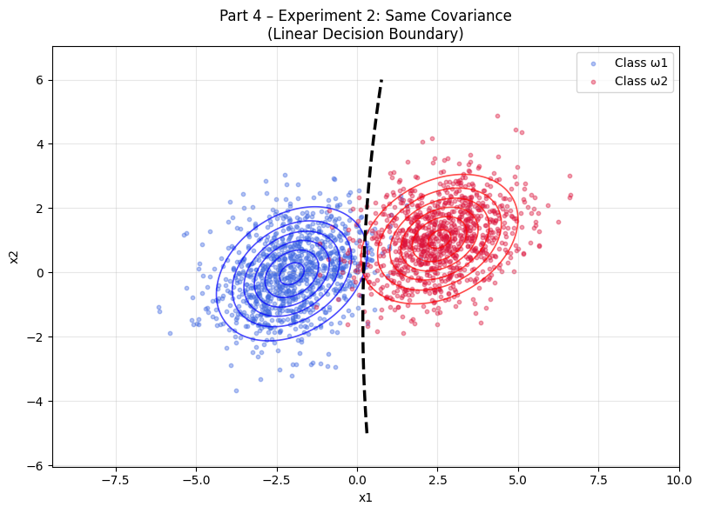
Observation(Experiment2):
When both classes have the same covariance matrix, the decision boundary becomes a straight line (linear).
Conclusion from Part 4:
- Different covariances - Quadratic (curved) decision boundary
- Same covariance - Linear (straight) decision boundary

OBSERVATIONS
- When the covariance is just a scaled identity matrix (σ²I), the density curves come out almost circular.
- When the covariance is diagonal, the ellipses are stretched along the x or y axis and are not tilted.
- When the covariance has off-diagonal terms (full matrix), the ellipses get rotated. The eigenvectors show the direction of the stretch and √λ shows how long each axis is.
- With 1000 samples, the estimated mean and covariance were already very close to the true values.
- When the two classes have different covariance matrices, the decision boundary becomes curved (quadratic). If both classes had the same covariance, the boundary becomes a straight line.

CONCLUSION
In this assignment we saw how the shape of a 2-D Gaussian changes with different types of covariance matrices. The eigenvalues and eigenvectors completely decide the size and orientation of the constant-density ellipses. We also saw that the decision boundary between two classes is linear only when both classes have the same covariance; otherwise it becomes quadratic.

